Page 1 **ROBOTICS**

*Moises, Christian James R.*

**Abstract.** Robotics is the study of the design, building, and use of machines (robots) to do jobs that were previously performed by humans. People are continuously interacting with the systems that surround them. Personal computers, vehicles, and smart appliances are just a few examples. Interactions with service robots in homes and offices are projected to become commonplace in the near future. The robotics and automation business has taken over industries ranging from manufacturing to home entertainment. It is frequently used due to its ease of use and ability to be modified to match changing needs. Robots are commonly utilized in areas such as vehicle manufacturing to perform simple repetitive jobs, as well as in areas where workers must work in dangerous situations. AI is used in many parts of robotics; robots may be endowed with the equivalent of human senses including vision, touch, and the ability to perceive temperature. Some are even capable of making simple decisions, and contemporary robotics research is focused on developing robots with a degree of self-sufficiency that will allow them to move around and make decisions in an unstructured environment. Robotic systems have been successfully deployed to accomplish specific jobs with varying degrees of intelligence throughout the past decade. Commercial robotics solutions are increasingly focusing on personal services. A final section suggests further readings for those who wish to delve deeper into robotics.

**Abbreviation and notation.**

AI (artificial intelligence)

Wireless local area network (Wi-Fi)

**Introduction.** In this research we will see how effective and how helpful robotics are in today’s stage. Mobile systems are currently widely employed in industrial automation, thanks to the widespread use of wireless technology. Mobile systems are being used to automate simple, repetitive mechanical activities. Automation, in its purest form, entails the abolition of all manual labor through the application of automatic controls that ensure

Page 2

precision and quality. Although perfect automation has never been realized, it has created changes in job patterns in their more limited form. With the advent of cybernetics by American mathematician Norbert

Wiener, the notion gained a larger connotation. Wiener predicted the use of computers in production scenarios through cybernetics. During the 1950s and 1960s, he caused consternation by incorrectly predicting that automatic technology would result in huge unemployment. However, automation did not take off as quickly as expected, and other economic variables have provided new job prospects. The development of powered machinery for production operations, the introduction of powered equipment to move materials and work pieces during the manufacturing process, and the perfecting of control systems to regulate production, handling, and distribution were three interrelated technological trends that led to automation. Auto parts are delivered quickly from inventories to the assembly line where they are assembled to generate cars in the automobile industry. It's possible that moving automotive parts is risky at times.

The Android structure comprises of programs running in a virtual machine with run-time compilation on a Java framework for object-oriented applications on the core library of C / C. Android is a robust operating system that is widely employed in current research in all disciplines that require mobile technology. They construct an application that tries to make real-time audio streams, for example, in. The transmission of high-quality audio is an essential area that is constantly expanding; however, most apps are developed on PC platforms, and they present an adaptable real-time solution in this job. The user would be able to create a path and then instruct the robots to follow it. The user can also save the path so that it can be reused without of having to re-define it every time. The system proposed is user-friendly. Using a mobile app, we created a Graphical User Interface (GUI). Through the application, you'd be able to control the robot.

Page 3

All parts of the manufacturing process were changed by automatic controls. The simple cam could automatically modify the position of a lever or machine element starting in the 19th century. Cam gadgets, on the other hand, were limited in terms of speed, size, and sensitivity. Only when the machine is sensitive enough to adjust to unexpected altering conditions can true automatic control be achieved. This requirement necessitates immediate feedback answers, which a computer can accomplish in a fraction of a second. While industrialization enabled bulk manufacture of identical items for mass markets, the computer enabled custom-made small-batch manufacturing. During the 1980s and 1990s, American businesses invested heavily in data processing equipment. These improvements allowed American firms to focus on “niche” production—that is, providing a specialized product to a small portion of the market and responding quickly to market demand changes. On the assembly line, niche production allows several automobiles with different options to be built on the same line, with computers monitoring a system that guarantees the correct items are put into each individual car. Through computer programming, the technology may be tailored to a specific product, allowing small quantities to attain many of the economies previously only attainable through mass manufacture of similar goods. Computer-aided design allows for the testing of manufacturing procedures and product design by using the computer to execute tests (such as the ability to bear stress, for example). Automation not only enables production flexibility, but it can also reduce costly lead times when switching from one production model to another, and it can control inventories to offer a continuous flow of materials without the need for expensive storage or spare parts expenditure. Automation has not yet progressed to the point where production is totally automated. Because they became confused by tiny variations in the objects on which they operated, the initial generation of industrial robots could only do simple operations like welding. The suggested system can control and run a robot that can (a) follow a user-defined path and (b) move objects from one location to another. Because the system is built on wireless technology, it is possible to control the robot from a distance.

Page 4

**Robot Description**

We've included several works that are directly relevant to ours in this section. We compare our work to that of others in the same field. In this area, we also discuss the novelty of our work. The goal of this project is to create a bi-directional communication architecture between a land rover robot and an Android device so that the robot may be controlled remotely. Create a robot prototype that fits these requirements, uses this architecture, and can be used act as a springboard for more sophisticated initiatives in the future. Then, using this design, build a robot prototype that fits these standards and can be used as a starting point for future, more sophisticated projects. Furthermore, it is envisioned that this platform can be used without the use of any gadgets or expensive equipment materials, so that as many individuals as possible have access to them.

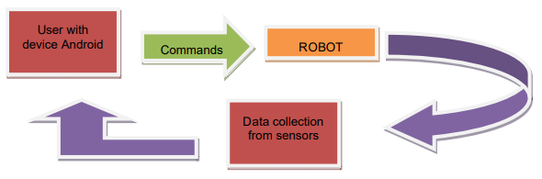A bidirectional communication system has been designed (see Figure 1) The user transmits commands to control the robot via Android to Arduino. Arduino to Android: The robot gathers data from its surroundings and sends it back to the Arduino the user for direct observation of the robot and its surroundings. This brings the communication to an end a loop

Fig. 1: Robot Description

Page 5

Low-cost commercial components were used to construct the robot. It is based on a toy vehicle with large enough wheels to allow mobility in terrain with ridges and slopes, and the rest of the components are installed on top of it: motors, sensors, and controllers the robot's design. Telerobots, which have been widely employed in numerous applications such as exploring undersea, outer space, and hazardous places, inspired the concept of networked robots. Telerobots have a number of drawbacks, one of which is their limited accessibility. Through a dedicated communication channel, only trained and expert users have access to the telerobots. Telerobots, on the other hand, have evolved in tandem with improvements in internet and networking technology. The telerobots have evolved into networked robots. By the year 2012, several hundred networked robots have been developed. This field has seen a lot of study and innovation, and it continues to do so. Even networked robots have been made available to the general population. A human-robot interaction system based on accelerometers has been presented in. An industrial robot with two low-cost, tiny 3-axis wireless accelerometers is used in the proposed system. These accelerometers are attached to the human arms in order to collect motion gesticulations and postures.

**TYPES OF ROBOTS.** Robotics is an area of engineering and science that encompasses electronics, mechanical engineering, and computer science, among other disciplines. This branch is concerned with the design, building, and use of robots, as well as sensory feedback and data processing. In the coming years, these are some of the technologies that will replace humans and human activities. These robots are designed to be utilized for a variety of tasks, however they are currently being employed in sensitive environments such as bomb detection and deactivation. Robots can take on any shape, although many of them have a human-like look.

Page 6

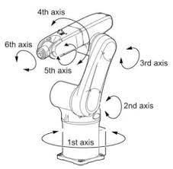**Articulated Robots**. A rotary-jointed robot is known as an articulated robot (e.g. a legged robot or an industrial robot). Simple two-jointed constructions to systems with ten or more interacting joints and materials are all examples of articulated robots. Electric motors are one of the many sources of power for them.

Fig. 2: Articulated Robots

**Cartesian Robot.** A Cartesian coordinate robot (also known as a linear robot) is an industrial robot with three main control axes that are all linear and at right angles to one another. Gantry robots are another name for these. The Cartesian coordinate system, i.e. x, y, and z, is used in these three joints. Wrists are fitted to these robots to give rotatory mobility.

Page 7

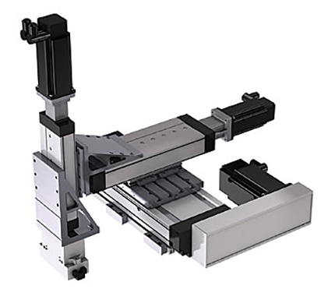

Fig. 3: Cartesian Robot

**Cylindrical Robot.** At least one rotary joint is located at the base of a cylindrical robot, and at least one prismatic joint connects the linkages. The rotary joint moves in a circular motion along the joint axis, while the prismatic joint travels in a linear motion. Their actions take place within a cylindrical work envelope. At least one rotatory joint and one prismatic joint are used to connect the links on these types of robots. Rotatory joints are used to rotate along an axis, while prismatic joints offer linear motion.

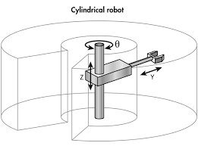Page 8

Fig. 4: Cylindrical Robot

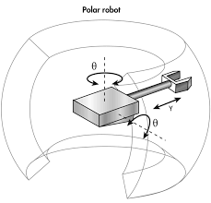**Polar Robots.** Polar robots have a combined linear joint and two rotational joints, as well as a twisting joint and an arm coupled to a robotic base. The axes create a spherical work envelope and a polar coordinate system, and are also known as spherical robots.

Fig. 5: Polar Robots

Page 9

**Scara Robot.** A SCARA robot is an industrial robot. Selective Compliance Assembly Robot Arm or Selective Compliance Articulated Robot Arm is the abbreviation. Assembly robots are the most common use for these robots. Its arm is shaped like a cylinder. It features two parallel joints that give compliance in a single plane.

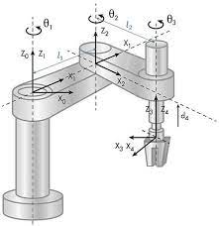

Fig. 6: Scara Robot

Page 9

* **Decryption:** Here, at last, is the breakthrough that cast the first bright spotlight on quantum computing. What makes encryption codes so difficult even for modern classical computers to break is the fact that they're based on factors of extremely large numbers, requiring inordinate amounts of time to isolate by "brute force". An operational quantum computer should isolate and identify such factors in mere moments, rendering the RSA system of encoding effectively obsolete. In 1994, MIT Professor Peter Shor devised a quantum algorithm for factoring values, which experimenters building low-qubit quantum systems have [already tested successfully](http://news.mit.edu/2016/quantum-computer-end-encryption-schemes-0303), albeit with rather small quantities. When large-qubit quantum computers are successfully built, few doubt the power of Shor's Algorithm to knock down all current public key cryptography.
* **Encryption:** But herein, some say, lies an opportunity: A concept called *quantum key distribution*(QKD) holds out the hope that the kinds of public and private keys we use today to encrypt communications may be replaced with quantum keys that are subject to the effects of entanglement. Organizations such as [Bethesda, Maryland-based QuantumXchange](https://quantumxc.com/how-does-quantum-key-distribution-work/)are building the first working QKD models today. Theoretically, any third party breaking the key and attempting to read the message would immediately destroy the message for everyone. Granted, that may be enough mischief right there. But the theory of QKD is based on a huge assumption which has yet to be proven in the real world: that *values* produced with entangled qubits are themselves entangled and subject to quantum effects wherever they go. QKD would require the deployment of *quantum networks* -- independent assemblies of QCs linked by optical fiber, through which these quantum-random values would be transmitted as photons. Not digits representing random values, mind you, but the actual photons whose polarity contains the random elements themselves.

**Conclusion**

The field of quantum computing is growing rapidly as many of today's leading computing groups, universities, colleges, and all the leading IT vendors are researching the topic. This pace is expected to increase as more research is turned into practical applications. Although practical machines lie years in the future, this formerly fanciful idea is gaining plausibility.

The current challenge is not to build a full quantum computer right away; instead to move away from the experiments in which we merely observe quantum phenomena to experiments in which we can control these phenomena. Systems in which information obeys the laws of quantum mechanics could far exceed the performance of any conventional computer. Therein lies the opportunity and the reward. No one can predict when we will build the first quantum computer; it could be this year, perhaps in the next 10 years, or centuries from now. Obviously, this mind-boggling level of computing power has enormous commercial, industrial, and scientific applications, but there are some significant technological and conceptual issue to resolve first.

Page 10

This paper identifies three classes of opportunities for AI researchers at the intersection of quantum computation, quantum theory and AI:

* Design quantum algorithms to solve problems in AI more efficiently;
* Develop more effective methods for formalizing problems in AI by borrowing ideas from quantum theory;
* Develop new AI techniques to deal with problems in the quantum world.

The first class of research is still in the initial stage of development, and not much progress has been made. Unfortunately, these reasons are valid for the problems in AI too. Some fragmented and disconnected research belonging to the second class have a long history, and some basic ideas can even be traced back to Niels Bohr. In recent years, research in this class has become very active, especially through the *International Symposium on Quantum Interaction* (2007–2009). But it seems that some of these works are quite superficial, and deeper theoretical analysis of the formal methods developed in these works are needed. In particular, more experimental research is required to test the effectiveness. It appears that research in the third class is making steady progress. My main concern is whether the AI techniques developed in this class of research will be useful in quantum physics and will be appreciated by physicists. Certainly, collaboration between AI researchers and physicists will highly benefit the development of this area. Perhaps, experience from bioinformatics can be used for reference where close collaboration between computer scientists and biologists frequently happens and leads to high impact research.

**Acknowledgement**.

I am grateful to my classmates for many helpful discussions and cheery editing sessions.

**References**

1. <https://www.researchgate.net/publication/305638494_Mobile_Based_Robotic_Wireless_Path_Controller>
2. <https://www.britannica.com/technology/robotics>
3. <https://www.britannica.com/topic/history-of-work-organization-648000/Automation#ref539159>
4. <https://www.researchgate.net>
5. <https://www.geeksforgeeks.org/robotics-introduction/>
6. <https://www.researchgate.net/publication/319384464_The_IoT_Technological_Maturity_Assessment_Scorecard_A_Case_Study_of_Norwegian_Manufacturing_Companies>
7. <https://www.futurelearn.com/info/courses/begin-robotics/0/steps/2845>
8. <https://mitsloan.mit.edu/ideas-made-to-matter/a-new-study-measures-actual-impact-robots-jobs-its-significant>
9. <http://lawoflaws.com/ou/roboticsconcl.htm>
10. <https://www.scribd.com/document/104547860/>

Page 11

1. S. Abramsky, B. Coecke, A categorical semantics of quantum protocols, in: Proceedings of the 19th Annual IEEE Symposium on Logic in Computer Science, pp. 415–425.
2. S. Abramsky, R. Duncan, A categorical quantum logic, Mathematical Structures in Computer Science 16 (2006) 469–489.
   1. Acín, Statistical distinguishability between unitary operations, Physical Review Letters 87 (2001), art. no. 177901.
3. D. Aerts, M. Czachor, Quantum aspects of semantic analysis and symbolic AI, Journal of Physics A: Mathematical and General 37 (2004) L123–L132.
4. T. Altenkirch, J. Grattage, A functional quantum programming language, in: Proceedings of the 20th Annual IEEE Symposium on Logic in Computer Science (LICS), 2005, pp. 249–258.
5. S.L. Andresen, John McCarthy: Father of AI, IEEE Intelligent Systems (September/October 2002) 84–85.
   1. Baltag, S. Smets, LQP: The dynamic logic of quantum information, Mathematical Structures in Computer Science 16 (2006) 491–525.
6. Barenco, C. Bennet, R. Cleve, D.P. DiVincenzo, N. Margolus, P. Shor, T. Sleator, J.A. Smolin, H. Weinfurter, Elementary gates for quantum computation, Physical Review A 52 (1995) 3457–3467.